Stress behavior of thin SnO₂ films on various substrates at high temperature

Alaide P. Mammanaª, Marcos H.M.O. Hamanaka^{b}, Thebano E. A. Santos^{b}, Daniel den Engelsenª and Carlos I.Z. Mammanaª
ªAssociação Brasileira de Informática, Av. Pe. Almeida Garret. 267, Jd. N. Sra. Auxiliadora, CEP 13087-290 Campinas, SP, Brasil
^{b}Centro de Tecnologia da Informação Renato Archer, Rodovia D. Pedro I, km 143,6, 13069-901 Campinas, SP, Brasil

Abstract
We deposited thin dioxide films by atmospheric pressure chemical vapor decomposition (APCVD) with tin tetrachloride as precursor in a flow of methanol and dry nitrogen on various substrates. The deposition was done at 430°C on alumina, soda lime glass and glass ceramic (Schott-Ceran) substrates, the thickness of the films varied between 80 and 2400nm. Unlike the films on alumina, which were mechanically stable, the films on glass ceramic showed cracks and caused an increase of the sheet resistance. The SnO₂ films showed good adherence on all substrate types before and after 5 weeks of heat cycling up to 500°C. The observed crack behavior of films on glass ceramic substrates is explained in terms of tensile stress.
Key words: atmospheric pressure CVD, thermal stress, tin tetrachloride, cracks, expansion coefficient.
- Introduction
Research and development on tin oxide are continuously increasing because of its application as oxidation catalyst, transparent conducting oxide in displays and solar cells, solid state gas sensor, transparent heating element and as material in thin film batteries. We are interested in fabricating heating elements of thin films of SnO_{2,} because SnO₂ is chemically inert against acids, scratch resistant and has a suitable resistivity to be applied as thin film heater. SnO₂ thin films are manufactured by using several techniques like spray pyrolysis, chemical vapor deposition (CVD), reactive sputtering and sol-gel methods. Large area coating is mainly done with sputtering and CVD [1-5].
CVD is capable to produce uniform coatings of SnO₂ on arbitrarily shaped substrates at low cost. In this study we made thin films of SnO₂ on various substrates by atmospheric pressure chemical vapor deposition (APCVD) using tin tetrachloride (SnCl4) and methanol (CH₃OH) as precursors and nitrogen as carrier gas.
The formation of SnO₂ from SnCl₄ and methanol by APCVD using dry nitrogen as carrier gas has been described by A. P. Mammana et al. [6, 7] and others [8, 9]. It is a simple and reliable method for fabricating thin films of SnO₂ at temperatures of ~400°C with a high transparency and high conductivity.
Apart from the long-term stability of SnO₂ at high temperature in air, the matching of the thermal expansion between film and substrate needs to be addressed for an application as heating element. This point did not receive much attention in the scientific literature up to now. For this reason we started a study of SnO₂ made by CVD on various types of substrates with different expansion coefficients. The linear expansion coefficient of SnO₂ is reported to lie between 3.7x10⁻⁶/K and 5.7x10⁻⁶/K [10-14]. We have selected substrates with linear expansion coefficients that are lower, almost equal and higher than the reported range for SnO₂. Preliminary results of our work were presented at LatinDisplay 2009, São Paulo [15].
This paper is organized as follows. Section 2 describes the experimental methods. Section 3 shows the experimental results of optical microscopy of the films before and after heat cycling and resistance measurements. Section 4 describes the analyses of the thermal stress of the SnO₂ films. Finally, section 5 summarizes the conclusions.
- Experimental methods
  - Thin film deposition
Thin films of SnO₂ were prepared by APCVD using SnCl₄ and methanol as starting materials. We constructed an experimental CVD equipment to deposit SnO₂ films on hot substrates and used dry N₂ as carrier gas. The principle of our coating equipment is depicted in Figure 1.
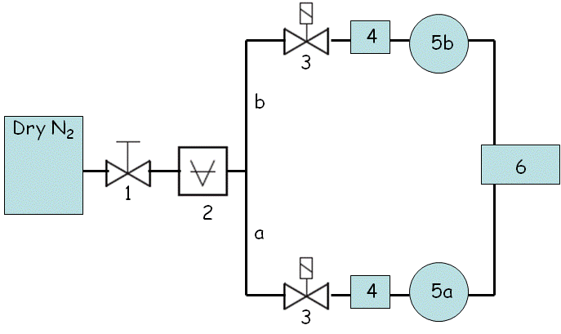
Figure 1. Lay-out APCVD equipment: 1 = reducing valve; 2 = measuring gauge for pressure; a = SnCl₄-branch; b = methanol (CH₃OH) – branch; 3 = valves to adjust flow rates in the two branches individually; 4 = flow meters; 5a = bubbler for SnCl₄; 5b = bubbler for CH₃OH; 6 = cold-wall reaction vessel.
The valves, indicated by 3 in figure 1, were used for adjusting the flow rates in the two branches. The carrier gas was saturated with vapor of the fluids in both bubblers, SnCl₄ (5a) and absolute CH₃OH (5b). SnCl₄ (industrial grade, purity 99.5%) was bought from Quirios, Brazil. The temperature of the bubblers was kept at 25°C in order to control the evaporation rate of SnCl₄ and CH₃OH. The reaction chamber was a cold wall Pyrex conical jar of 22 cm height with two gas inlets. This vessel was mounted over a horizontally rotating (at 10 rpm) stainless steel hot-plate holding the substrate. The temperature of the substrates was adjusted and controlled with thermocouples.
We made experiments to study the influence of the substrate. We deposited SnO₂ on Ceran, being a glass ceramic material with a very low linear expansion coefficient, on sintered alumina and on soda lime glass. The size of the sintered alumina and soda lime substrates was 15x15mm² and that of the glass ceramic substrates was 150x150mm².The substrates were ultrasonically cleaned in a neutral detergent, then rinsed with de-ionized water and finally flushed with isopropyl alcohol before inserting in the reaction vessel.
The SnO₂ films were grown at temperatures in the range between 330 and 430°C, using deposition times between30 seconds and 30 minutes in N₂ flow rates of 750 sccm for CH₃OH and 250 sccm for SnCl₄. By varying the deposition time, we made films with thicknesses between 40 and 2400nm. The film thickness was found to be linear with the deposition time.
The SnO₂ layers were contacted with commercial Ag-pastes that were baked at high temperature. For temperatures up to 500°C we used Ticon 9070/1 (Brazil) and for temperatures >500°C we used ceramic based Ag-pastes, Ticon 4081BLA and Ticon 1150 resp. These Ag-contacts enabled Joule heating of the SnO₂ layers in ambient air and conducting heat cycling experiments without placing samples in a furnace.
2.2 Thin film characterization and testing
The SnO₂ films and the connecting silver contacts were investigated with an optical microscope, before and after heat cycling tests. The thickness of the thin films was measured with a stylus type apparatus, DEKTAK 3030. Steps in the SnO₂ films were made by etching the thin films with Zn-powder in HCl.
The electrical resistance of the SnO₂ films was measured with a 4-points probe before and after heat cycling.
Heat cycling was done by applying 90V (60Hz AC) voltage to the silver contacts. One heat cycle was 5 minutes on and 5 minutes off. For the prolonged tests, heat cycling was continued for 5 weeks. The temperature of the films during the heating tests was measured with a thermocouple (to 400°C) and two types of IR-sensors, Minolta Cyclo 33CF for temperatures 400-600°C and Raytek Model MX for temperatures > 600°C.
The resistance of the silver contact films was checked separately before and after heat cycling.
- Results
Figure 2 shows the resistivity of the SnO₂ films on sintered alumina and glass ceramic substrates as a function of thickness. The films were deposited at 430°C. The resistivity of the SnO₂ films on alumina is 2x10⁻³Ωcm for a film thickness of 2400nm. The resistivity of the thin films on both substrates was 4x10⁻³Ωcm between 400 and 1200nm, whereas at thickness >400nm the resistivity increased to 7.5x10⁻³Ωcm.
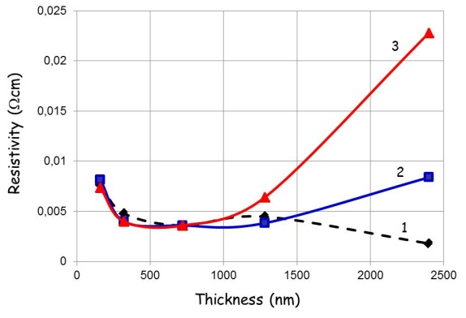
Figure 2. Resistivity of SnO₂ thin films on sintered alumina (1) and glass ceramic without shelf life (2) and after 96 hours of shelf life (3).
The behavior of the resistivity of the SnO₂ films on alumina and glass ceramic substrates for small thicknesses can be explained in terms of the Fuchs-Sondheimer theory [16, 17]. This theory describes the effect of scattering of conduction electrons in (very) thin films. This scattering becomes important when the ratio of the film thickness to the electronic mean free path becomes small. In other words, it is to be expected that the resistivity increases at small thickness, say at thickness smaller than 400nm.
In the case of glass ceramic we observed an effect of shelf life for large thicknesses: the resistivity of the thick films increased substantially during storage in ambient air. However, the resistivity of the 2400nm SnO₂ film on glass ceramic directly after depositing (and cooling down to ambient temperature) is also significantly larger than the resistivity of the corresponding film on alumina.
The behavior of the resistivity of the SnO₂ films on glass ceramic is ascribed to the formation of cracks. We chose deliberately glass ceramic material from Schott for our experiments, because it has a very low thermal expansion coefficient of -0.01x10⁻⁶/K [18]: therefore, it is a popular material to be used in cook tops. Figure 3 shows optical microscope pictures of SnO₂ on glass ceramic.
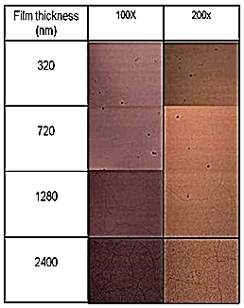
Figure 3. Optical microscope pictures of SnO₂ thin films on glass ceramic.
It can be seen that films >1280nm show cracks. This result differs strongly from the experiences described by Auding et al. [10] regarding the mechanical stability of SnO₂ on quartz glass and glass ceramic. In contrast to glass ceramic substrates, the SnO₂ films on alumina did not show cracks, not even after a heat cycling test with a top temperature of 500°C that was continued for 5 weeks.
The adherence of the SnO₂ films to the various substrates was investigated with the tape and scratch (sapphire point with 25mg force) tests. These tests indicated a good adherence to all substrates and high resistance against mechanical loads.
- Analysis of stress
The total stress σ in a thin film can be written according to Campbell [19] as:
(1),
where σ_{e} is the external stress due to external forces, σ_{t} is the stress caused by thermal effects and σ_{i} is the intrinsic stress, caused by nucleation and growth of the thin film. In the following analysis we shall neglect external and intrinsic stresses and only consider thermal stress σ_{t}. The thermal stress σ_{t} in a thin film cooled down from the temperature of deposition T_{h} (no stress situation) to room temperature T_{r} can be written as [20]:
(2),
where α_{f} is the linear expansion coefficient of the thin film, α_{s} is the expansion coefficient of the substrate, E_{f} is Young’s modulus of the thin film and ν_{f} is Poisson’s ratio of the film. This equation refers to a thin film of an isotropic and linearly elastic material on an isotropic and linearly elastic substrate. Because of slight texturing, our thin SnO₂ films were not completely isotropic; however, we shall neglect this in the following consideration.
Table 1 shows the relevant data for SnO₂ and the various substrates used in our study. The last row of table 1 shows the thermal stress, calculated in the tin oxide film upon cooling down from the deposition temperature of 430°C (no stress) to 25°C.
Table 1: Mechanical properties of SnO₂ and substrates
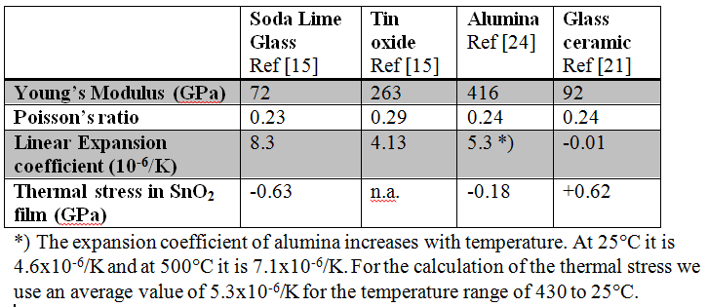
When α_{f} > α_{s}, σ is tensile (σ > 0) after cooling down: this will be the case for glass ceramic. In the case of soda lime glass and alumina, the thermal stress in the thin film is negative and the film is under compression after cooling down.
While a compressive stress will not immediately lead to cracks, a tensile stress of 0.5-1GPa usually does [20]. Our experiments with SnO₂ films on alumina did not show any cracks, neither after cooling down after depositing nor after repeating heat cycling up to 500°C. This may be understood, because the rather small compressive stress in the film is well below the fracture limit. However, on ceramic glass we observed cracks in the films with a thickness >1280nm after being cooled down to room temperature. The calculated thermal stress in the layer of 0.62GPa is rather large and this large stress caused the crack pattern as shown in figure 3. In thin (<1280nm) SnO₂ films on glass ceramic, we could not detect cracks. It should be noted that after two weeks of heat cycling of a SnO₂ film on alumina to 650°C some cracks were observed in the thin film. As our films show excellent adherence to all substrates, one may expect that very thin films may withstand high tensile stress without cracking as is indeed observed in our experiments with glass ceramic. Nevertheless, from our experiments it can be concluded that glass ceramic is not a preferred substrate for thin film heaters made of SnO₂.
From the foregoing analysis we conclude that we have fairly good agreement between a theoretical evaluation of the stress in thin SnO₂ films and our experimental observation of cracks after heat cycling.
- Conclusions
We found that thin films of SnO₂ made by APCVD from a SnCl₄ precursor in a flow of methanol show low resistivity. The resistance of the thin films is stable upon prolonged heat cycling in air, indicating that they can be applied in heater elements up to 600°C.
The mechanical stability of the SnO₂ films on alumina substrates is good and does not show any mechanical or electrical degradation after heat cycling tests. This indicates that alumina is a good substrate to be used with thin films of SnO₂ in heater applications.
The thermal stress in SnO₂ films thicker than 1280nm on glass ceramic (Ceran) causes cracks: glass ceramic is therefore not a good substrate for heater applications with SnO₂ films. The crack formation in SnO₂ films on glass ceramic substrates can be understood by evaluating the tensile stress in these films.
- References
[1] R. G. Gordon, MRS Bulletin, 52, August 2000.
[2] J. M. Blocher, Jr., Thin Solid Films 77(1981) 51.
[3] E. Giani and R. Kelly, J. Electrochem. Soc. 121(1974) 394.
[4] R. N. Ghoshtagore, J. Electrochem. Soc. 125(1978) 110.
[5] A. M. B van Mol, Ph.D. Thesis (2003), Technical University of Eindhoven, The Netherlands (ISBN 90-386-2715-7); available at: http://alexandria.tue.nl/extra2/200313223.pdf
[6] A. P. Mammana, Patent deposited in INPI, N° 8.002.761, (1980).
[7] V. Baranauskas et al., Sensors and Actuators B: Chemical, 85 (2002), 90.
[8] Y. Matsui, Y. Yamamoto and S. Takeda, Mat. Res. Soc. Symp. Proc. 621 (2000), Q4.9.1-Q4.9.6.
[9] Y. Gotoh and M. Mizuhashi, Asahi Garasu Kenkyu Hokoku 34(1984)123.
[10] H. Auding et al., US 4889974, Philips (1989).
[11] Gmelin, Handbuch der anorganischen Chemie, 8. Auflage, Zinn, Teil C1, Verbindungen, Springer, Berlin (1974), 72.
[12] D. J. Green, Glass Technol. 41 (2000) 48.
[13] M. Batzill and U. Diebold, Progress in Surface Science 79 (2005) 47.
[14] E. P. Sverdrup, D. H. Archer and A. D. Glasser, ACS Fuel Volume 1967, Fall Chicago 11 (1967) 229.
[15] A. P. Mammana et al., Proceedings of LatinDisplay (2009), 139, São Paulo, Brazil, November 16-19.
[16] K. Fuchs, Proc. Cambridge Philos. Soc. 34 (1938), 100.
[17] E. H. Sondheimer, Adv. Phys. 1 (1952), 1.
[18] Schott Technical Glasses, Mainz, December 2000.
[19] D. S. Campbell in Handbook of Thin Film Technology, Edited by L.I. Maissel and R. Glang, McGraw-Hill Book Company, New York, Reissue 1983, pp 12-22.
[20] E. E. Gdoutos, Fracture Mechanics, An Introduction, Second Edition, Springer, Dordrecht (2005), p 331.
[21] http://www.ceramics.nist.gov/srd/summary/scdaos.htm

