Resistance behavior of thin SnO₂ films
at high temperature
Alaide P. Mammanaª, Marcos H.M.O. Hamanaka^{b}, Thebano E. A. Santos^{b}, Lisandro P. Cardoso^{c}, Daniel den Engelsenª and Carlos I.Z. Mammanaª
ªAssociação Brasileira de Informática, Av. Pe. Almeida Garret. 267, Jd. N. Sra. Auxiliadora, CEP 13087-290 Campinas, SP, Brazil
^{b}Centro de Tecnologia da Informação Renato Archer, Rodovia D. Pedro I, km 143,6, 13069-901 Campinas, SP, Brazil
^{c}Institute of Physics Gleb Wataghin, UNICAMP, CEP 6165, 13083-970 Campinas, SP, Brazil

Abstract
Tin oxide (SnO₂) films were deposited by atmospheric pressure chemical vapor decomposition (APCVD) in a cold-wall reactor with tin tetrachloride (SnCl₄) as precursor in a flow of methanol (CH₃OH) and dry nitrogen. The deposition was done at 430°C on alumina, soda lime glass and glass ceramic (Schott-Ceran) substrates, the thickness of the films varied between 80 and 2400nm. X- ray diffraction spectra showed that the films were polycrystalline with tetragonal rutile structure.
The resistivity of the SnO₂ films on alumina varied between 2x10⁻³ and 4x10⁻³Ωcm for thicknesses between 700 and 2400nm. The resistance of the films up to 600°C showed a metallic behavior with a temperature coefficient of +0.002Ω/°C.
The resistivity and the positive temperature coefficient of the resistance of our SnO₂ films are discussed in terms of non-stoichiometry and Cl doping.
Key words: atmospheric pressure CVD, thermal stress, tin tetrachloride, Cl-dope
- Introduction
Research and development on tin oxide are continuously increasing because of its application as oxidation catalyst, transparent conducting oxide in displays and solar cells, solid state gas sensor, transparent heating element and as material in thin film batteries. We are interested in fabricating heating elements of thin films of SnO₂: this application relies on the free electrons originating from the ionization of dopants or oxygen vacancies in the SnO₂ lattice [1].
SnO₂ thin films are manufactured by using several techniques like spray pyrolysis, chemical vapor deposition (CVD), reactive sputtering and sol-gel methods. Large area coating is mainly done with sputtering and CVD [1-5].
CVD is capable to produce uniform coatings of SnO₂ on arbitrarily shaped substrates at low cost. In this study we made thin films of SnO₂ on various substrates by atmospheric pressure chemical vapor deposition (APCVD) using tin tetrachloride (SnCl4) and methanol (CH₃OH) as precursors and nitrogen as carrier gas.
The formation of SnO₂ from SnCl₄ and methanol by APCVD using dry nitrogen as carrier gas has been described by Mammana et al. [6, 7] and others [8, 9]. It is a simple and reliable method for fabricating thin films of SnO₂ at temperatures of ~400°C with a high transparency and high conductivity.
Thin films of SnO₂ have been proposed as heating elements in a variety of devices [10, 11]. In this application, the stability of the resistance at high temperature in air is very important. Some researchers [12, 13] observed a large increase of the resistance of thin films of SnO₂ at high temperature in air, whereas Spannhake et al. [11] found that Sb-doped SnO₂ thin films have stable resistance at high temperature in air.
We were interested whether our technology of depositing SnO₂ with SnCl₄ precursor in methanol yielded stable electrical resistance during high temperature tests in air and could be used as a process for manufacturing thin film heaters. Preliminary results of our work were presented at LatinDisplay 2009, São Paulo, November 16-19 [14]. Apart from the resistance stability, we also investigated the thermal stress in thin films of SnO₂ in more detail. The results of this study have been published separately and we refer to that study as Part 1 [15].
This paper is organized as follows. Section 2 describes the experimental methods. Section 3 shows the experimental results of XRD and resistance measurements. In section 4 we describe models for the conductivity of SnO₂ at ambient and high temperature. Finally, section 5 summarizes the conclusions.
- Experimental methods
  - Thin film deposition
Thin films of SnO₂ were prepared by APCVD using SnCl₄ and methanol as starting materials. We constructed an experimental cold-wall CVD reactor to deposit SnO₂ films on hot substrates and used dry N₂ as carrier gas. The principle of our coating equipment has been described in Part 1 [15].
The SnO₂ films were grown at temperatures in the range between 330 and 430°C, using deposition times between30 seconds and 30 minutes in N₂ flow rates of 750 sccm for CH₃OH and 250 sccm for SnCl₄. By varying the deposition time, we made films with thicknesses between 40 and 2400nm. The film thickness was found to be linear with the deposition time.
The SnO₂ layers were contacted with an Ag-paste that was baked at high temperature. For temperatures up to 500°C we used Ticon 9070/1 (Brazil) and for temperatures >500°C we used ceramic based Ag-pastes, Ticon 4081BLA and Ticon 1150 resp. These Ag-contacts enabled Joule heating of the SnO₂ layers without placing samples in a furnace.
  - Thin film testing
The SnO₂ films and the connecting silver contacts were investigated with an optical microscope, before and after heat cycling tests. Information on the grain size of the SnO₂crystallites, their preferential orientation in the SnO₂ thin films was investigated by X-ray diffraction (XRD) with the Philips PW1170 diffractometer equipped with a Fe-anode: K_{α}= 0.1939nm.
The thickness of the thin films was measured with a stylus type apparatus, DEKTAK 3030. Steps in the SnO₂ films were made by etching with Zn-powder in HCl.
The electrical resistance of the SnO₂ films was measured with a 4-points probe before and after heat cycling.
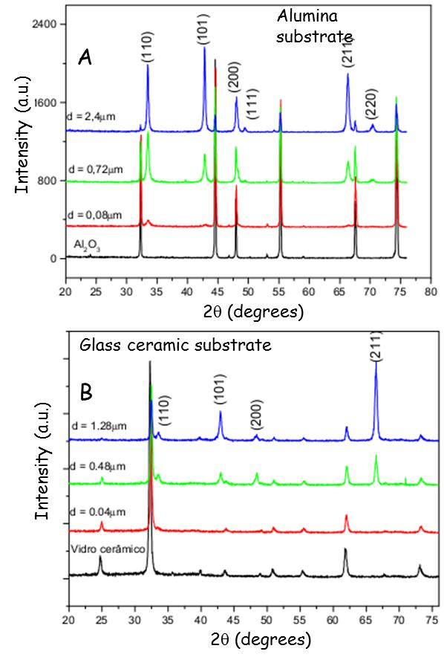
Figure 1. XRD-diagrams of SnO₂ thin films on alumina (A) and glass ceramic substrates (B).
Heat cycling was done by applying 90V (60Hz AC) voltage to the silver contacts. One heat cycle was 5 minutes on and 5 minutes off. For the prolonged tests, heat cycling was continued for 5 weeks. The temperature of the films during the heating tests was measured with a thermocouple (to 400°C) and two types of IR-sensors, Minolta Cyclo 33CF for temperatures 400-600°C and Raytek Model MX for temperatures > 600°C.
The resistance of the silver contact films was checked separately before and after heat cycling.
- Results
Figure 1 shows X-Ray Diffraction (XRD) graphs of SnO₂ films deposited on alumina and glass ceramic substrates. The films on both substrates are polycrystalline and the SnO₂ crystal lattice is tetragonal (rutile). The preferential orientation of the crystallites on alumina and glass ceramic is different as can be noticed in these graphs. From the difference in peak heights of the (110) and (101) reflection signals at 720 nm and 2400 nm on alumina it can be concluded that there is some texturing in the films. From the full widths at half maximum (FWHM) of the strongest peaks in the XRD-diagrams depicted in figure 1, we can calculate the crystallite size with Scherrer´s equation, assuming that the shape factor is 1. This gives an average value for the crystallite diameter of 29nm.
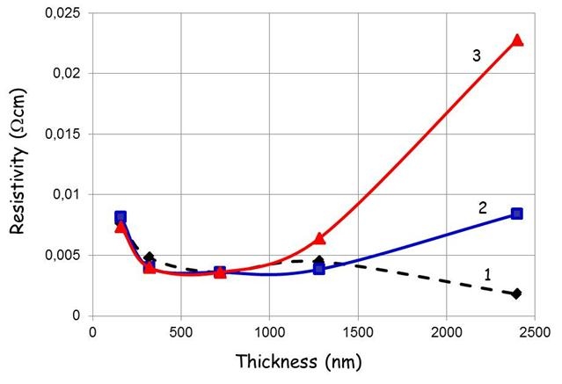
Figure 2. Resistivity of SnO₂ thin films on sintered alumina (1) and glass ceramic without shelf life (2) and after 96 hours of shelf life (3).
Figure 2, which was also presented in [15], shows the resistivity of the SnO₂ films on sintered alumina and glass ceramic substrates as a function of thickness. The films were deposited at 430°C. The resistivity of the SnO₂ films on alumina is 2x10⁻³Ωcm for a film thickness of 2400nm. The resistivity of the thin films on both substrates was 4x10⁻³Ωcm between 400 and 1200nm, whereas at thickness >400nm the resistivity increased to 7.5x10⁻³Ωcm. The resistivity represented in figure 3 agrees well with resistivity values of thin SnO₂ films deposited with CVD, published in ref. [5] on page 39.
The increase of the resistivity of the SnO₂ films on alumina substrates for small thicknesses can be interpreted in terms of the Fuchs-Sondheimer theory as described in Part 1 [15].
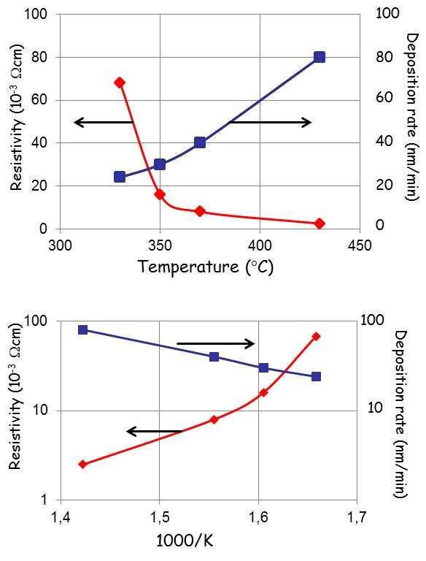
Figure 3. Resistivity and deposition rate of SnO₂ films on soda lime glass versus temperature. Top diagram linear scale, bottom diagram are the Arrhenius plots of the same data.
Figure 3 shows the resistivity of tin oxide thin films on soda lime glass deposited between 330 and 430°C. Linear and semi-log (Arrhenius) plots are depicted. For films deposited at 330°C the resistivity was 6.8x10⁻²Ωcm and at 430°C it was 2.5x10⁻³Ωcm: almost a factor of 30 smaller. The deposition rate is also indicated in this figure. It increases by a factor of 4 in the temperature range of 330-430°C.
Both Blocher [2] and Ghoshtagore [4] discussed the rate of SnO₂ film formation with APCVD. At relatively low temperatures the reaction between adsorbed water and SnCl₄ is rate-determining and shows Arrhenius-type dependence with temperature [2]. Although the temperature range of figure 3 is limited, the activation energy for the deposition reaction can be estimated from the data presented in figure 3 and is found to be 42kJ/mol. We are studying this mechanism in more detail and like to report on this mechanism in near future.
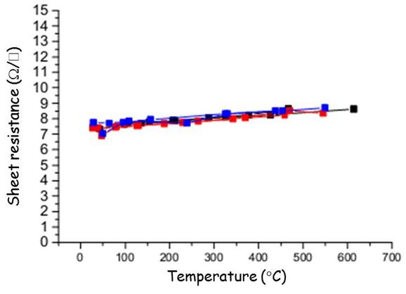
Figure 4. Sheet resistance of 2400nm SnO₂ film on alumina as a function of temperature.
Figure 4 shows the variation of the sheet resistance of a 2400nm SnO₂ film on alumina as a function of temperature. The temperature coefficient of the sheet resistance between room temperature and 600°C is +0.002Ω/°C. The positive temperature coefficient of the resistance indicates that the SnO₂ material prepared in our CVD reactor is a degenerate semiconductor with the resistance behavior of a metal. Figure 4 shows measurement data after heat cycling up to 500°C, which was continued for 5 days. This indicates that the resistance of our SnO₂ films is stable during prolonged heating periods in air. This result is quite different from the large increase of the resistance of SnO₂ films upon heating in air as published in Gmelin’s Handbook [13].
- Conductivity model
We shall present in this section two hypotheses that could explain why the resistance of our SnO₂ films is stable up to 600° in air and why the value of the resistivity of SnO₂ is in the lower range of the values published by van Mol [5], page 39.
We shall discuss the resistivity and high temperature stability of our SnO₂ films in terms of two well-known models: (1) non-stoichiometry and (2) doping of SnO₂ with Cl. The latter doping is non-intentional; this has been suggested earlier by van Mol [5] and Smith et al. [16]. Let´s consider Table 1, in which we compare the resistivity of thin SnO₂ films deposited with CVD with resistance data of Samson and Fonstad from crystals [17].
Table 1.
Comparison of resistivity of SnO₂ thin films deposited at different conditions.
 | CVD with Cl-containing precursors Ref. [5], p39 | CVD without Cl-containing precursors Ref. [5], p39 | Samson & Fonstad Low temp. 1) Ref. [17] | Samson & Fonstad  Oxygen vacancy 2)  Ref. [17]
ρ (Ωcm) | 4.4x10⁻³ 3) | 2.2x10⁻² 4) | 5.9 | 1.1
T(°C) | 350-550 | 300-500 | 700 | 1090
P_{O2} (mbar) | 0-100 | 0~100 | 25 | 30

- Temperature range in which SnO₂ resistivity did not depend on oxygen pressure, resistivity measured at high temperature
- Lowest temperature for which resistivity depended on oxygen pressure, resistivity measured at high temperature
- Average value. Extremely thick SnO₂ films and films deposited at 600-800°C were excluded; resistivity measured at room temperature.
- Average value, resistivity measured at room temperature.
We did not insert the data of Maier and Göpel [18] in Table 1, because the resistivity found by these latter authors is 14 orders of magnitude larger than the values determined by Samson and Fonstad. Table 1 shows 4 columns, the first providing the average resistivity of thin SnO₂ films made by CVD from Cl-containing precursors from 13 different sources, the second column is provides the average resistivity of SnO₂ films made by CVD from precursors that do not contain Cl. The third column shows the result of Samson and Fonstad at 700°C, which is the lowest temperature in their study [17]. At this temperature their SnO₂ samples did not respond to changes of the partial O₂ pressure, P_{O2}. At higher temperatures, they found that the resistivity is proportional with P_{O2}^{0.15}, which proved that the conduction in SnO₂ was due to oxygen vacancies according to the reaction:
2O_{O} → 2V_{O}´´ + O₂ + 4e (1),
where, in the Kröger-Vink notation, O_{O} is an oxygen ion at an oxygen lattice site and V_{O}´´ is a doubly charged oxygen vacancy. In a perfect match with Eq. (1), the resistivity must vary proportional with P_{O2}^{0.167}. The resistivity measured by Samson and Fonstad at high temperature was orders of magnitude higher than the resistivity of thin SnO₂ films, measured at room temperature. Mizusaki et al. [19] found that the non-stoichiometry, i.e. oxygen deficiency, of SnO₂ annealed in low oxygen pressures is very low; furthermore, they found that heating SnO₂ below 900°C at oxygen pressures up to 1atm resulted in adsorption of oxygen on the SnO₂ surface. This agrees with Samson and Fonstad´s results [17], because their data refer to bulk conduction in SnO₂ crystals by compensating for surface conduction as much as possible. From the data represented in Table 1 it is not particularly obvious to explain the resistivity of SnO₂ films deposited by CVD and other techniques in terms of non-stoichiometry, because one needs to assume large concentrations of oxygen vacancy or large non-stoichiometry.
Although large oxygen deficiency has never been reported experimentally in thin SnO₂ film to our knowledge, we cannot exclude O-deficiency being the cause of the low resistivity determined in our SnO₂ films. We made our SnO₂ thin films at a temperature of 430°C in methanol vapor. At that temperature methanol could decompose into syngas (H₂ + CO), which creates a reducing atmosphere close to the substrate. If H₂ is formed, it induces the following reaction:
O_{O} + H₂ → V_{O}´´ + H₂O + 2e (2).
So, we could explain our results by assuming that (1) we form syn-gas, (2) create a much a larger non-stoichiometry than determined by Mizusaki et al. [19] and, (3) heating of our SnO₂ thin films in air leads to surface adsorption of O₂ onto the SnO₂ surface, which is not affecting the bulk resistance. In this model, the oxygen deficiency of SnO₂ does not change upon heat cycling: it could be considered to be “frozen” up to 600°C.
We shall now describe the second model, viz. non-intended doping of SnO₂ with Cl. Non-intentional doping by Cl is a hypothesis that is based on the observation that SnO₂ thin films made from Cl-containing precursors have a lower resistivity than those made from non-Cl containing precursors [16]. This hypothesis is supported by the data represented in Table 1, indicating that the average resistivity generated by Cl-containing precursors is about 5 times smaller than that generated by precursors without Cl. Cl is an n-type dopant for SnO₂ like F, since Cl can substitute O at an oxygen lattice site according to
2O_{O} + Cl₂→ 2Cl_{O}• + O₂ + 2e (3),
where Cl_{O}• is a chlorine ion at an oxygen lattice site. It is positively charged, because a Cl-atom at the O-site will absorb only one electron to get ionized, whereas the original O-atom absorbs two electrons.
In deposition experiments with slightly different flow rates of the carrier gas than mentioned in section 2.1, we found a concentration of 1%Cl (molar) in our SnO₂ films with Rutherford backscattering (RBS).
The ion radius of Cl⁻ (167pm) is much larger than the ion radius of O²⁻ (126pm); this may explain the reason that it is impossible to dissolve Cl in SnO₂ at concentrations >1% [20]. Dhere et al. [21] also detected Cl in SnO₂ films made by CVD from SnCl₄ as precursor; however, they did not mention the concentration.
Smith et al. [16] and Miki-Yoshida & Andrade [20] found that the resistivity varied between 3x10⁻³ and 14x10⁻³Ωcm for SnO₂ films made with a SnCl₄ precursor solution in an oxidizing atmosphere containing O₂. Korotkov et al. [22] have recently argued that the relation between Cl-containing precursors and the resistivity of SnO₂ films made by APCVD is less convincing as suggested by Smith et al [16].
If we assume, based on our RBS-measurements, that 1% of the O-sites in the SnO₂ lattice is occupied by Cl⁻ -ions, then the electron concentration in the lattice will be 2.8x10²⁰/cm³ in order to maintain electro-neutrality according to Eq. (3). Assuming a value of 13cm²(V.s)⁻¹ for the mobility of the conduction electrons [21-23], the resistivity of the SnO₂ film is calculated to be 1.7x10⁻³Ωcm, which is in fair agreement with our experimental value of 2x10⁻³Ωcm.
Cl-doping of SnO₂ is not only beneficial for generating low resistivity; it makes the thin films also insensitive to changes of the stoichiometry: the resistivity is only controlled by the doping level and hence, changes in the concentration of O-vacancies are immaterial. These changes could be induced by heating of the films at high temperature in air, as discussed in the previous model.
The temperature coefficient of the resistance of non-doped SnO₂ films is reported to be negative and for doped films it is positive [11, 23]. The temperature coefficient of the resistivity of our films is positive (figure 4), which could be used as an argument in favor of Cl-doping.
It should be stressed that both conductivity models for SnO₂, non-stoichiometry and Cl-doping, are hypotheses, which cannot explain our results completely satisfactory. The difficulty with the non-stoichiometry model is (1) that we don´t know whether we are producing syn-gas during the deposition of SnO₂ in CH₃OH and (2) that the resistivity determined by us is far outside the resistivity found in SnO₂ at low oxygen pressure for which the non-stoichiometry model was proven. The difficulty with the Cl-doping model is that we cannot prove from our experiments and analyses that Cl sits on an O-site in the SnO₂ lattice and generates conduction electrons as indicated by equation (3). Finally, in both models presented here, it is difficult to explain why some authors found small resistivity of thin SnO₂ films made by CVD without Cl-containing precursors in O₂-containing gas, as shown in the second column of Table 1. We are planning experiments to clarify these issues.
- Conclusions
We found that thin films of SnO₂ made by APCVD from SnCl₄ and methanol had a low resistivity with a positive temperature coefficient.
The resistance our SnO₂ films was stable upon prolonged heat cycling in air, indicating that they can be applied in heater elements up to 600°C.
The stability of the SnO₂ films on alumina substrates was good and did not show any electrical degradation after heat cycling tests. This indicates that alumina is a good substrate to be used with thin films of SnO₂ in heater applications.
We discussed the low resistivity and the positive temperature coefficient of the resistance of our SnO₂ films in terms of non-stoichiometry and Cl doping. Non final conclusion on the resistivity model could be drawn from the experiments presented in this paper.
Acknowledgement
We like to thank Professor Manfredo H. Tabacniks of the Physical Institute of the University of São Paulo for measuring the Cl content in our SnO₂ films with Rutherford Backscattering.

- References
[1] R. G. Gordon, MRS Bulletin, 52, August 2000.
[2] J. M. Blocher, Jr., Thin Solid Films 77(1981) 51.
[3] E. Giani and R. Kelly, J. Electrochem. Soc. 121(1974) 394.
[4] R. N. Ghoshtagore, J. Electrochem. Soc. 125(1978) 110.
[5] A. M. B van Mol, Ph.D. Thesis (2003), Technical University of Eindhoven, The Netherlands (ISBN 90-386-2715-7); available at: http://alexandria.tue.nl/extra2/200313223.pdf
[6] A. P. Mammana, Patent deposited in INPI, N° 8.002.761, (1980).
[7] V. Baranauskas et al., Sensors and Actuators B: Chemical, 85 (2002), 90.
[8] Y. Matsui, Y. Yamamoto and S. Takeda, Mat. Res. Soc. Symp. Proc. 621 (2000), Q4.9.1-Q4.9.6.
[9] Y. Gotoh and M. Mizuhashi, Asahi Garasu Kenkyu Hokoku34(1984)123.
[10] H. Auding et al., US 4889974, Philips (1989).
[11] J. Spannhake et al., Sensors6 (2006) 405.
[12] A. De and S. Ray, J. Phys. D Appl. Phys. 24(1991) 719.
[13] Gmelin, Handbuch der anorganischen Chemie, 8. Auflage, Zinn, Teil C1, Verbindungen, Springer, Berlin (1974), 84-86.
[14] A. P. Mammana et al., Proceedings of LatinDisplay (2009), p 139, São Paulo, Brazil, November 16-19, (2009).
[15] A. P. Mammana et al., Proceedings of LatinDisplay 2012/IDRC 2012, São Paulo, Brazil, November 26-28, (2012).
[16] A. Smith et al., Thin Solid Films 266 (1995) 20.
[17] S. Samson and C. G. Fonstad, J. Appl. Phys. 44(1973) 4618.
[18] J. Maier and W. Göpel, J. Solid State Chem. 72 (1988), 293.
[19] J. Mizusaki et al., J. Solid State Chem. 88 (1990), 443.
[20] M. Miki-Yoshida and E. Andrade, Thin Solid Films 224 (1993) 87.
[21] R.G. Dhere et al., National Center for Photovoltaics Program Review Meeting(1998), Denver, Colorado, September 8-11
[22] R. Y. Korotkov, P. Ricou, A.J.E. Farran, Thin Solid Films 502 (2006) 79.
[23] H. de Waal and F. Simonis, Thin Solid Films 77(1981) 253.

