AURAL:

Robotic Navigation as a Musical Composition Strategy

Artemis Moroni, Josué Ramos, Sidney Cunha and Jônatas Manzolli*

CTI Renato Archer, Rod. D. Pedro I, km 143, 6, 13069-901 – Campinas - SP, Brazil

*NICS/UNICAMP, Rua da Reitoria, 165 – Cid. Universitária "Zeferino Vaz", 13083-872 – Campinas – SP - Brazil

ABSTRACT
This paper describes sensing systems and mobile robotic platforms that were developed as multimodal robotic artistic installations for sound production. AURAL, an evolutionary mapping of trajectories of the robots into sound events is compared to AURAL2, a generative soundscape associating virtual and real world for sound production. The behavior of mobile robots in an arena is applied as a compositional strategy. This research is oriented towards the study of automatic and semi-automatic processes of artistic production.

INTRODUCTION
Robotic installation art unifies Installation art and robotic technologies insofar as the works and installations often employ computers, sensors, actuators and programming which allow them to respond or evolve in relation to viewer interactions. In this kind of art and technology-based work the viewer is transformed from a passive viewer to an active participant.

Robotic Trajectories and Evolution
In the AURAL, a robotic installation for sound production, the visitor draws on the computer display a curve which is sent as a trajectory (sequence of points) to a master robot traverse in an arena. The robot is tracked by an omnidirectional vision system, specially built for this usage (Figure 1). The path followed by the robot generates another curve. The coordinates of the points of both curves, the trajectory and the path, supplies parameters (Melody, Harmoy) for the evaluation of a sound fitness function. This function is applied to a population of chords of four musical notes, continuously generated by an evolutionary algorithm, and selects a chord to be played. Other robots moving in the arena modify the sound performance, by their location and the distance among them. The sound result resembles a chord cadence or a fast counterpoint of note blocks.

AURAL2: Robots and Sound Recycling
In AURAL₂, the sound production is the result of a generative process. Sound fragments are inserted into a database – the memory of the system - and each fragment is linked with a region in a virtual grid. The grid, a sound matrix, is associated with a winding stage. The movement of the robots across the different regions of the stage triggers sounds from the matrix, (re) creating soundscapes in the installation environment. On a display, the virtual grid and the cells activated by the robots are presented in different angles, as a scenery. Furthermore, local sounds are captured from time to time or through the interaction of visitors with a microphone. The acute sounds change the color of the cells to red, the bass sounds to blue. The sounds captured from the environment are then re-entered into the matrix replacing a previous one, feeding a recycling acoustic process. Thus AURAL2 intervenes in the sound ecology of the environment, creating new aural paths with everyday sounds.

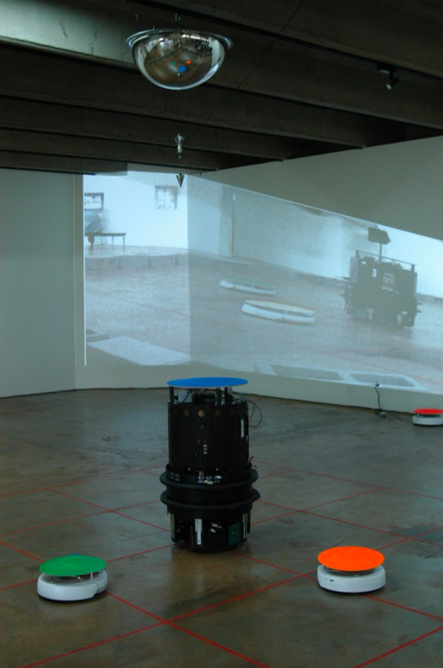 | 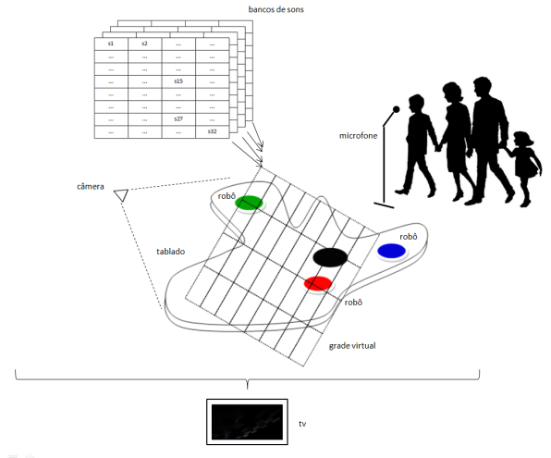
 | 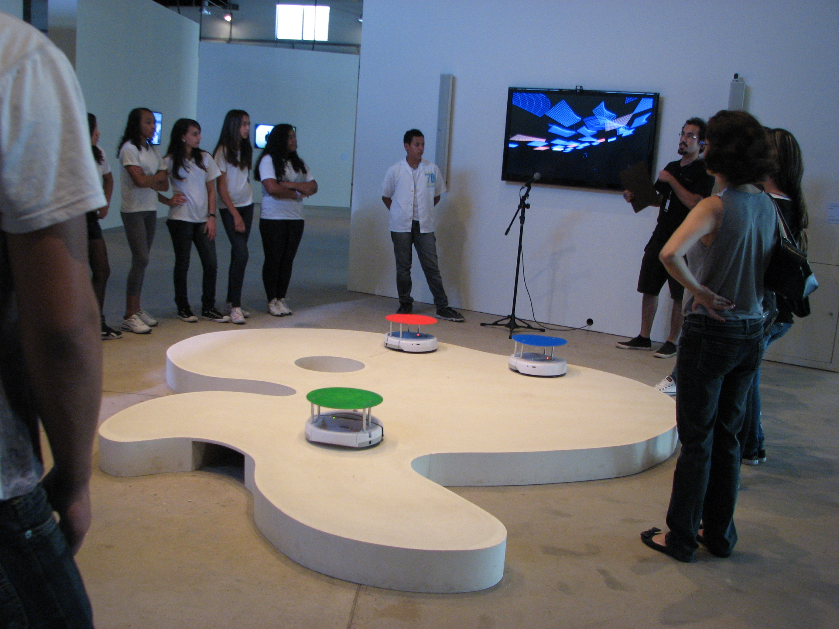
Fig. 1 On the left, the robots. Hanging on the ceiling, the omnidirectional vision system. On the right, AURAL₂. Above, the mapping of the sound matrix with the winding stage.

Conclusion
In AURAL, the interaction between robots, sensing systems and people results in an audiovisual performance exploring the possibilities of synthetic creativity. In this environment the strategies of the composer, artist, engineer, public and machines are different processes that intertwine in a unique texture where material (sound, movement and images) and ideas (concepts of composition) blend.

REFERENCES
[1] A. Moroni and J. Manzolli. “From Evolutionary Composition to Robotic Sonification”. In: EvoApplications 2010. Applications of Evolutionary Computation. Berlin: Springer, 2010.

Please, save as .DOC, DOCX, .RTF or ODT file to upload in the LatinDisplay 2012 site.

