A new method for studying the kinetics of wet etching thin films of ITO

Suelene S. Mammana*, Alessandra Greatti*, Francis H. Luiz*, Francisca I. da Costa*, Alaide P. Mammana*, Daniel den Engelsen* and Carlos I. Z. Mammana*

*abinfo – Associação Brasileira de Informática, Av. Pe. Almeida Garret. 267 · Jd. N. Sra. Auxiliadora, CEP13087-290 Campinas - SP – Brasil, e-mail: cizm@uol.com.br

ABSTRACT

We describe a new and simple method to study the kinetics of wet etching thin ITO films by monitoring the resistance of the thin film during the etching process. This method enables studying etch rates between 0.1 and ≈150nm/min.
Generally three different regimes can be distinguished: (1) initial etching, which is slow, (2) a fast bulk etching phase and (3) slow etching stage at the end. We show that our method is especially suited to study phenomena at the end of the etching process, in which isolated patches of the film are still adhering to the substrate.

Key words: Indium tin oxide, methodology, wet etching, kinetics, resistance.

INTRODUCTION
Due to its rather high electrical conductivity and optical transparency, indium tin oxide (ITO) is one of the most widely used transparent conductive oxides (TCO) for displays, touch panels, solar cells and other related applications. Patterning of thin films of ITO is usually done with lithography, which includes an etching step that is mostly wet etching in industrial processes.
In studies on wet etching of ITO, the procedure to evaluate the etch rate is usually not explicitly mentioned [1-6]. Since the focus in those studies is on overall etch rates, it is likely that the etch rate is evaluated by dividing the film thickness by the total etch time. However, it is not mentioned how the total etch time is determined. The underlying assumption for the evaluation of the etch rate is that it is constant during the etching process.
The study of the etch rate during etching a thin film of ITO and other transparent conductive materials such as SnO₂ and ZnO requires monitoring of thickness or mass related quantities of the film. Optical monitoring methods can be ellipsometry, direct transmission and reflection measurements or measuring the transmission and reflection through a grating structure [7], because for very thin films (<50nm) direct measurements of transmission and/or reflection are inadequate to evaluate the thickness. Preparing a grating structure in an ITO-film requires an etching technique that avoids under-etching. Since this is not always possible in partly amorphous ITO-films, we did not consider applying this technology. Jacobs et al. [8] and van den Meerakker et al. [9] described a monitoring process, in which the decrease of the thickness of an ITO-film covered with a photoresist pattern was measured after various time intervals of etching. The monitoring was not done in situ: the sample was taken out from the etching solution, cleaned, dried and then the layer thickness of the etched surface was measured with a contact profilometer. This method may also suffer from under-etching; moreover, measuring the thickness for very thin ITO-films is cumbersome, because of surface roughness and formation of isolated ITO-residuals on the substrate surface.
For monitoring the etch rate during etching, we apply a resistance-related measuring technique, which does not require photolithographic techniques to prepare samples and which may have problems as mentioned above. Moreover, the electrical conductivity is one of the most important properties of transparent oxide films such as ITO. Resistance is a convenient parameter to be measured and it is directly related to the electrical properties of the devices obtained by an etching process. Our new method is not limited to ITO, but may be applied in studying the kinetics of etching various types of conducting films.
The outline of this paper is as follows. After describing the essential elements of the resistance monitoring method during etching, we discuss the shape of the resistance monitoring curves and show that from these curves one can obtain more relevant etch rates for ITO.

MONITORING OF THE RESISTANCE
We designed a method for monitoring the resistance during etching of thin films of ITO in acidic etchants such as hydrochloric acid (HCl) and oxalic acid (H₂C₂O₄). This monitoring was done in the following way: every minute the sample was removed from the etching solution and the resistance was measured outside the solution. We chose deliberately for this way, because measuring the resistance in situ, while the film was in the etching solution, suffered from parasitic currents in the conductive etching solutions. Before measuring, the sample was cleaned for 1 minute in distilled water at 50°C in an ultrasound bath, rinsed with distilled water and alcohol and dried at 100°C. This procedure limited the minimum etch time to one minute, while the time needed to remove the sample from the solution and washing in distilled water to stop the reaction was routinely 7 seconds, which did not contribute significantly to the error in determining the etch time. No alkali was used to stop the reaction, ensuring that no additional reagents were adsorbed on the ITO-surface during the measurements.
We measured the resistance of the samples through parallel contacts separated by 10 mm, which yielded 2 squares in parallel, so that the sheet resistance was two times the measured resistance. The measuring jig is depicted in figure 1. A specially constructed jig for assuring stable and low contact resistance was built. It was made of a cantilever pulled by a string with adjustable length that could apply a force of up to 4 kg to a tool that pressed the sample against two conductors made of tinned copper-woven strands. These wires were parallel within 100µm (deviation from parallelism <1%) by a PVC separator. We refer to this resistance measurement as the 2-strips method.
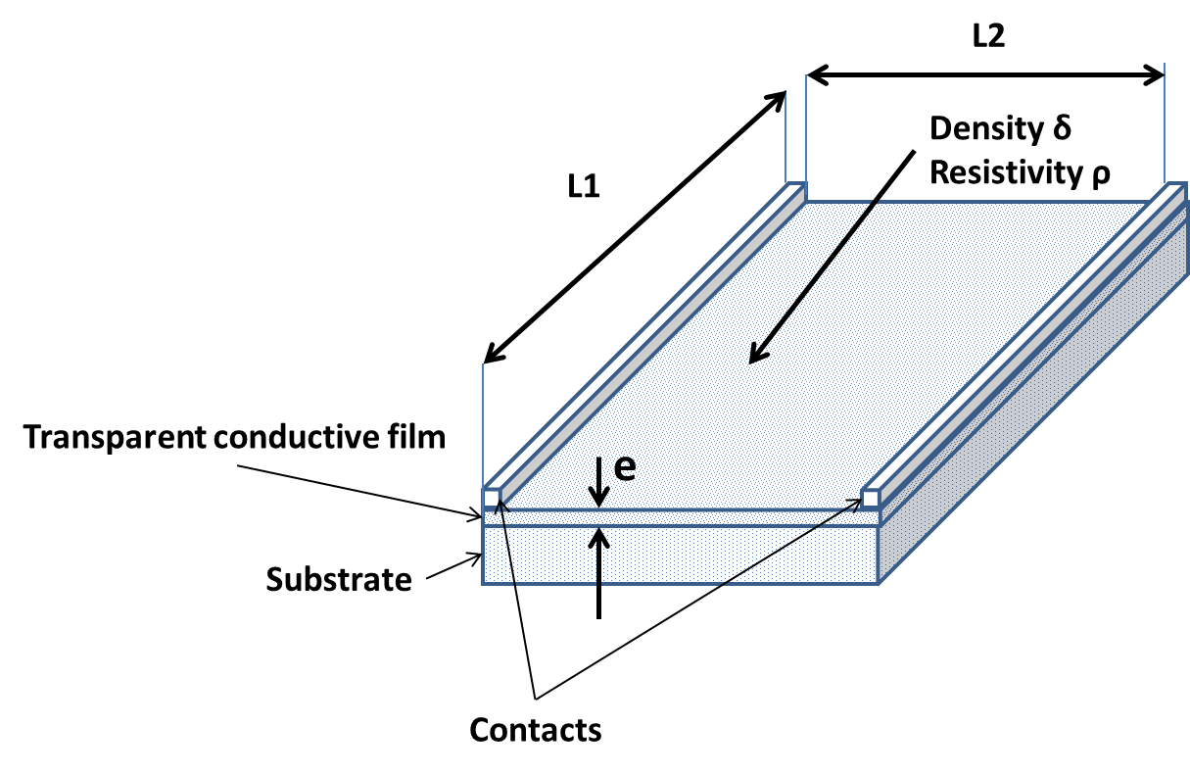

Fig. 1 Jig for measuring the resistance showing the position of the contacts

The resistance was measured with a two electrode ohmmeter.
The sheet resistance of thin ITO films is high enough to enable also the use of a 4 point measurement. In that case the resistance was measured with a Jandel HM21 4-point probe head, equipped with tungsten carbide needles separated by 1mm. The difference between the 2-strips and the 4-point probe measurements was less than 10 %. Repeatability of the 2-strips measurements was tested for a series of 20 measurements at the same sample, applying and releasing the pressure on the sample to simulate the conditions of the experiment. The mean deviation of the resistance measurements was better than 0.5%. The jig permitted fast measurements of the resistance during the etching.

ETCH RATE AND ENDPOINT
We etched ITO-films with two different thicknesses, 25 and 175nm, in oxalic acid and hydrochloric acid. During etching, the resistance of the 25nm ITO film increased from the initial value of 98Ω/ to infinite. The change of the normalized reciprocal value of the resistance during the etching process is represented in figure 2.
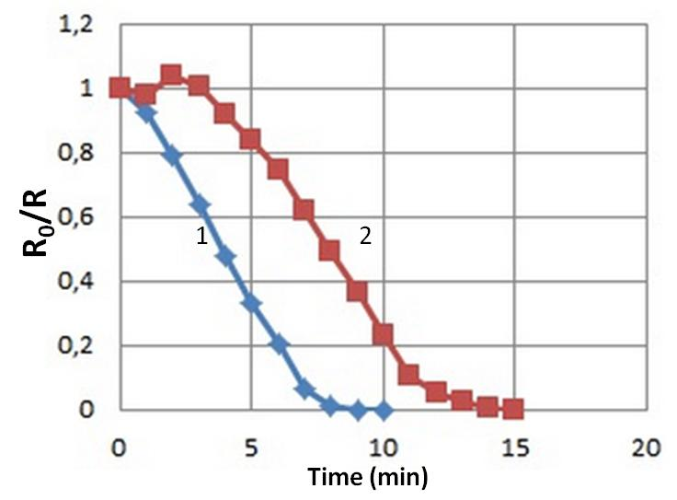
Fig. 2 R₀/R versus time of ITO etching in 0.32M oxalic acid at 60°C. Curve 1: with extran degreasing. Curve 2: without degreasing in extran.
The vertical axis in figure 2 indicates R₀/R, where R₀ is the initial sheet resistance before etching and R is the actual sheet resistance, measured during etching in the way as described in the previous section.
Figure 2 shows that rigorous degreasing of the ITO thin film affects the initial etching behavior. For that reason we decided to degrease our samples in 5% Extran® MA02 before etching. This process reduced the initial etch time in most cases.
The shape of a typical R₀/R-time diagram is indicated in figure 3.
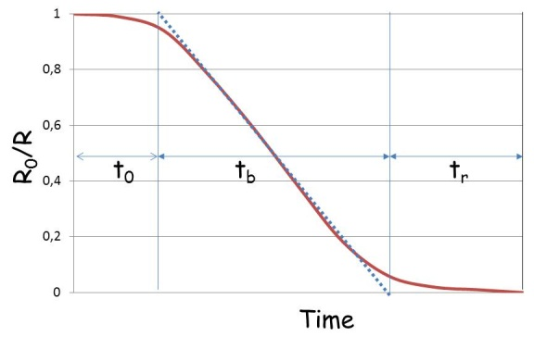
Fig. 3 Shape of R₀/R diagram. t₀ is onset etching time, t_{b} is bulk etching time, and t_{r} is residual etching time.
The total etching time t_{etch} is the time measured from the start of the reaction to the point where the resistance is at least 10⁷ times larger than the resistance of the non-etched film. For our ITO-films, with sheet resistances before etching of about 10 and 100 Ω/, the resistance must increase to about 10⁸ Ω/. We stopped etching, when the measured resistance of the samples exceeded 200 MΩ. Since this criterion does not assure that all the material has been removed from the glass surface, extra attention has been be paid to the end phase of the etching process.
The curve in figure 3 shows 3 phases for the etching process during the total etching time t_{etch}: an initial etch period with slow etching indicated by t₀ (onset time), a rather fast decrease of R₀/R during t_{b} (bulk etch time) and a slow etching at the end t_{r} (residual etching time), where t_{etch} = t_{o} + t_{b} + t_{r}.
The onset time t_{o} is defined as the time, in which the linear behavior starts and t_{r} is defined as the time elapsed from the end of this linear portion until R₀/R is smaller than 10⁻⁷. The transitions between the regimes can be determined by plotting the first and second time numerical derivatives of R₀/R_{t}.
Let us consider the etch rate de/dt (in nm/min), where e indicates the thickness of a uniform, isotropic film in a solution that is well stirred and that also has a large excess (~10⁴) of etchant molecules as compared to ITO-molecules. If there is no autocatalytic effect of reactants, then de/dt is constant: in other words, e decreases linearly with time. The initial thickness of the film is indicated by e₀ and after some time in the etching fluid we have e_{t}. The initial sheet resistance R₀ at t=0 is

(1a),
where ρ is the resistivity of the film, not being a function of z (coordinate normal to the surface) for an isotropic film. After t minutes the sheet resistance is
(1b).
In other words, for a uniform film the quantity R₀/R_{t} is proportional with e_{t} and equal to the normalized thickness, e_{t}/e₀. The ITO etch rate is calculated by dividing the film thickness, 25nm, by the etch time for the bulk, t_{b}.
In equations (1a) and (1b) the resistivity of a conducting thin film is considered to be independent of the thickness. This is generally not true in thin films, since at small film thicknesses one observes an increasing effect of electron scattering at the film surfaces due to the fact that the electron free path is larger than the film thickness. This leads to a deviation from the bulk resistivity and one observes larger resistivity in thin films at > ~300nm. The observed increase of resistivity for small film thicknesses is traditionally interpreted in terms of the Fuchs-Sondheimer theory that was formulated in the 1930-1950s [10, 11]. Benoy et al. found that the resistivity of ITO films, deposited by evaporation, increased by a factor of 2 below 100 nm [12]. They interpreted this phenomenon in terms of the Fuchs-Sondheimer effect.
In this preliminary report on the methodology of etching thin films of ITO, we shall neglect the Fuchs-Sondheimer effect, since non-uniformities due crystallite morphology and electrical connectivity between crystallites may play an even larger role when the film gets thinner and thinner upon etching.
Figure 4 shows some typical R₀/R curves obtained during etching ITO films with oxalic acid. From the R₀/R curve the bulk etch rate can readily be calculated, i.e. e₀/t_{b}. This etch rate is considered to be more reliable than the etch rate evaluated from the total etch time t₀ + t_{b} + t_{r}, because that will under estimate the etch rate. The etch rate for the 25nm film represented in figure 4 is 4.6nm/min and the etch rate for the thick film is 5.3nm/min.
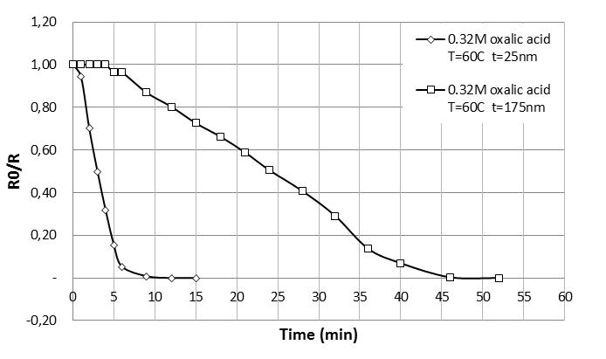
Fig. 4: Etching 25nm and 175nm ITO-films in 0.32M oxalic acid at 60°C.
The slow decrease of R₀/R in the final stage of the etching process shown in figures 2 and 4A is not attributed to humidity effects in the residual film. This conclusion could be drawn after measuring the resistance at various levels of humidity. Whether residual water plays a role in the electrical conduction of an almost completely removed ITO-layer is a subject of future investigation.
ITO films consist of clusters of crystallites that are non-uniformly distributed as a function of thickness [1]. During etching this non-uniformity becomes clearer and can be studied with a SEM: this will be described in our second paper on this subject, indicated by Part 2 [13]. During the final etching phase t_{r}, the film can no longer be considered to be homogeneous, neither regarding resistivity nor regarding etch rate, because the crystallites are less and less connected. Unconnected clusters of material may remain, so that additional etch time is necessary to complete the fabrication process. On top of that, the deposition technique of ITO may give rise to non-uniformities as has been described by Jacobs et al. [8] and Benoy et al. [12].
As mentioned above, the initial etching behavior is strongly affected by the degreasing process. We shall therefore assume that slow, initial etching rate is primarily caused by surface contamination (grease, dust, etc.). At the end of the etch process one observes isolated ITO islands on the glass; this will be described in detail in Part 2 [13]. As long as the ITO crystallites have contacts with each other, the resistance has a finite value. In the case of isolated ITO crystallites it is assumed that the resistance will be infinite. This transition is expected to be sharp in the case of uniform islands: similar to the transition from percolation to non-percolation. In most cases we did not observe a sharp transition from finite resistance to infinite (>10MΩ) resistance. Thus, a simple percolation-based model for the resistance at the end of the etch process cannot explain our results. A possible explanation for our results could be that we have ionic conduction on the glass surface between the isolated ITO islands. This could be caused by the formation of a NaIn_{x}O_{y} compound, due to the diffusion of Na into the ITO film during post annealing after deposition.
We think that a good etchant to be applied in electrical devices fabrication must have short t_{o}- and t_{r}-times, and a reproducible and as short as possible etch time t_{b} in the linear phase of the etch process.

CONCLUSIONS
We present a new method to study the kinetics of wet etching of conductive thin films by monitoring the resistance. The method has been tested for thin films of ITO of 25 and 175nm. This new method yields insight in the course of the etching process. Generally three different phases can be distinguished: an initial phase with a very slow etch rate, a fast etch rate for the majority of the film and again a slow etch rate at the end. Etch rates based on recording the total etch time will generally underestimate the relevant etch rate: we propose to calculate the etch rate from the time linear phase in the R₀/R curve. Furthermore, we think that our method is especially suited to study phenomena at the end of the etching process.

REFERENCES

[1] M. Hoheisel et al., “Microstructure and etching properties of indium-tin oxide”, Phys. Stat. Sol. (a) 123, 461 (1991).
[2] S.A. Bashar, “Study of indium tin oxide (ITO) for novel optoelectronic devices”, PhD Thesis King´s College London (1998).
[3] T.-H. Tsai and Y.-F. Wu, “Wet etching mechanism of ITO films in oxalic acid”, Microelectronic Eng., 83, 536-541 (2006).
[4] T.-H. Tsai and Y.-F. Wu, “Organic acid mixing to improve ITO film etching in flat panel display manufacturing”, J. Electrochem. Soc. 153, C86-C90 (2006).
[5] K.W. Lee, “ITO etching composition”, Patent Nr. WO 00/11107 (2000).
[6] S. Morozumi in “Liquid Crystals – Applications and Uses”, Vol. 1, Ed. B. Bahadur, page 183, World Scientific Publishing Co., Singapore (1990).
[7] G.F. Mendes, “Lithografia na Microeletrônica”, PhD Thesis University of Campinas, September 13, 1984 (in Portuguese).
[8] J.W.M. Jacobs et al., “Microstructural and electrochemical aspects of wet etching ITO films”, in “Thin Film Transistor Technologies III”, Ed. Y. Kuo, Electrochemical Society Proceedings, 158 (1997).
[9] J.E.A.M. van den Meerakker et al., “On the mechanism of ITO-etching in halogen acids: the influence of oxidizing agents”, J. Electrochem. Soc. 142, 2321 (1995).
[10] K. Fuchs, Proc. Cambridge Philos. Soc. 34 (1938), 100.
[11] E. H. Sondheimer, Adv. Phys. 1 (1952), 1.
[12] M. D. Benoy et al., “Thickness dependence of the properties of infium tin oxide (ITO) films prepared by activated reactive evaporation”, Brazilian Journal of Physics, 39, 629 (2009).
[13] S.S. Mammana et al., “Etching of thin films of ITO in oxalic acid”, Proceedings of LatinDisplay 2012/IDRC 2012 (2012).

