Instructions for Preparing a Full Paper or an Extended Abstract for the Proceedings of LatinDisplay 2020

Fernando Ferrario, Viviane da Silva*, Olivier B. Bommel** and Renata Santana***

Cyber Space Laboratories, 3255 Avenida dos Bandeirantes, 04100-160-São Paulo-SP, Brazil

*Optisat, 3000 Rua Prof. Nivaldo Braga, 82900-160-Curitiba-PA, Brazil

**Toonder Universty, 2000 Dikkebomenbos, 2311AT Rommeldam, The Netherlands

***Centro de Pesquisas José Vidal, Rua 11 de Agosto, 13013-150-Campinas-SP, Brazil
fernandoferrario@xxxx.com.br

Abstract
You are submitting a paper. Follow this Template as model. A 50- to 100-word abstract is required at the beginning of the manuscript. The content of the paper does not need to be original, but new research work is recommended.
According to their relevance, full manuscripts of papers presented at LatinDisplay 2020 may be recommended for publication in the “Journal of the Society for Information Display” (JSID).
The paper must be written preferably in English; however Portuguese, Spanish will be accepted as well.

Introduction
In this article, we describe the instructions for a manuscript (paper) for the Proceedings of LatinDisplay 2020.. The article must be typed in accordance with these instructions. You can use this form as a template of your manuscript. To ensure proper reproduction, authors should follow the instructions below.

Title
The title of the paper should be the same as the title of the poster presented at the Poster Session of LatinDisplay 2020.

Authors
The presenting author should be underlined.

Format
- The manuscript must be on A4 size paper, in two-column format.
- The top, left, right, and bottom margins should be 25 mm. Allow 8 mm for the column spacing.
- For good readability, the font size of your manuscript should be 9 point. Arial font is recommended.
- Symbol, Wingdings or Zapf Dingbats Fonts (αβχδφγηκλµνοπθστυωξψζ∂∑∆) are recommended for typing any math functions or Greek symbols. These special symbols can be inserted by using the insertion function for symbols and special characters in the MS-word menu.

Length
Although there is no maximum limit, we recommend authors to limit full papers to 8 pages and extended abstracts to 2 pages.

Headings & Subheadings
Major heading must be in Arial 14 and centered in one column format. Headings must be in Arial 12 and must be aligned to the left side of the columns. Sub-heading must be in Arial 10 and aligned at the left side of the column.

Photos and Figures

Sub-heading Color Photos and Figures
Color images will be kept in the electronic proceedings. Test your figures to guarantee that they have an adequate resolution and color. See examples in Figure 1, Figure 2, and Figure 3.
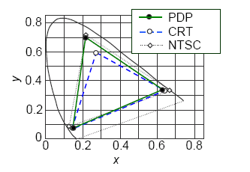
Fig. 1. Color figures will appear in the electronic version.
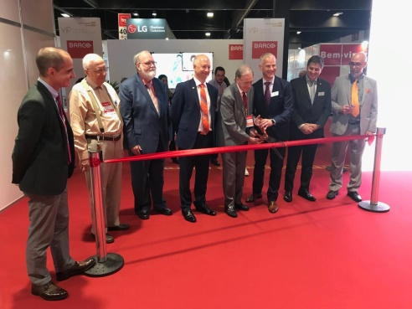
Fig. 2. -Color rendering and resolution must be adequate.
Figures may be positioned in the text for easy referring.

Fonts in Photos and Figures
If you need to type text in photos or figures, Helvetica, Arial, and Symbol fonts are strongly recommended.

Numbering and Captions
All photos and figures must be captioned with a figure number (and/or photo number), title and description. For good readability, the font size in your figure captions (legend) should be 9 point (see Figure 1). Use italics for the captions.

Gray Backgrounds
Avoid gray backgrounds in your figures as they may impair their appearance in the proceedings.

ELECTRONIC DATA
Electronic data for your manuscript, abstract or extended abstract are required. Prepare the electronic files of your manuscript (full paper or extended abstract) and short abstract in .doc, .docx or .odt format. The LatinDisplay Program Committee will add paper number and page numbers electronically to the received files. Please don’t set a password on your document.

SUBMISSION
The authors must send the manuscripts (full paper or extended abstract) and short abstracts before indicated deadline. Submit the electronic versions of your manuscript and abstracts in .doc, .docx or odt format at the LatinDisplay 2020 website.

REFERENCES
[1] I. Dickerdack, “Towards the Industrial Application of Sandwich Spread”, J. Sandwich, Vol. 2, pp. 3-4 (2003).
[2] K. Sikbock and T. Poes, “Mechanical Properties and Fracture Analysis of Grass”, Journal Irreproducible Results, Vol. 21, pp. 481-484, (2003).

Please, save as .DOC, DOCX or ODT file to upload in the LatinDisplay 2020 site.

